Dear Quilt Shop/ Fabric Shop Owner,

I am interested in fabric designs I have seen on Facebook Live and/or YouTube using Coco Chic, a fabric collection which was inspired by Art Deco, Roaring 20’s fabrics. I am hoping it will be available in your store.

Here is the link where you can find the collection on the QT Fabrics Website: http://www.qtfabrics.com/fabrics/search-results.asp

There are 17 different fabrics in the collection. QT Fabrics is the oldest fabric mill in the United States and they have archives going back to the early 1800’s. To create the collaboration, Blue Bear Quilts and QT Fabrics scoured the archives, looking for art deco fabrics from the 1920’s. They modernized the fabrics with today’s colors and combined elements from different fabrics.

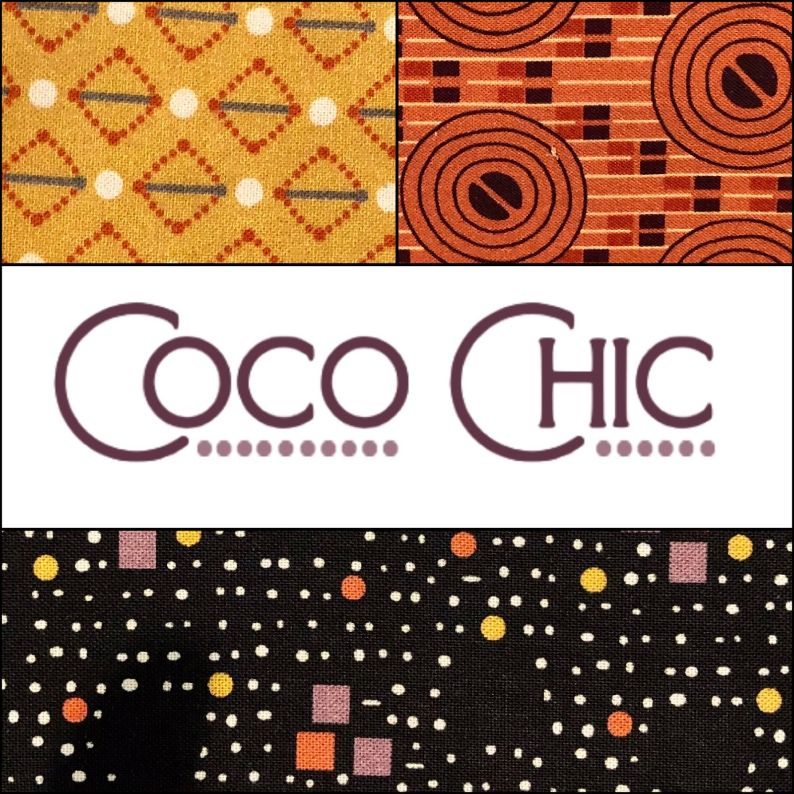 | 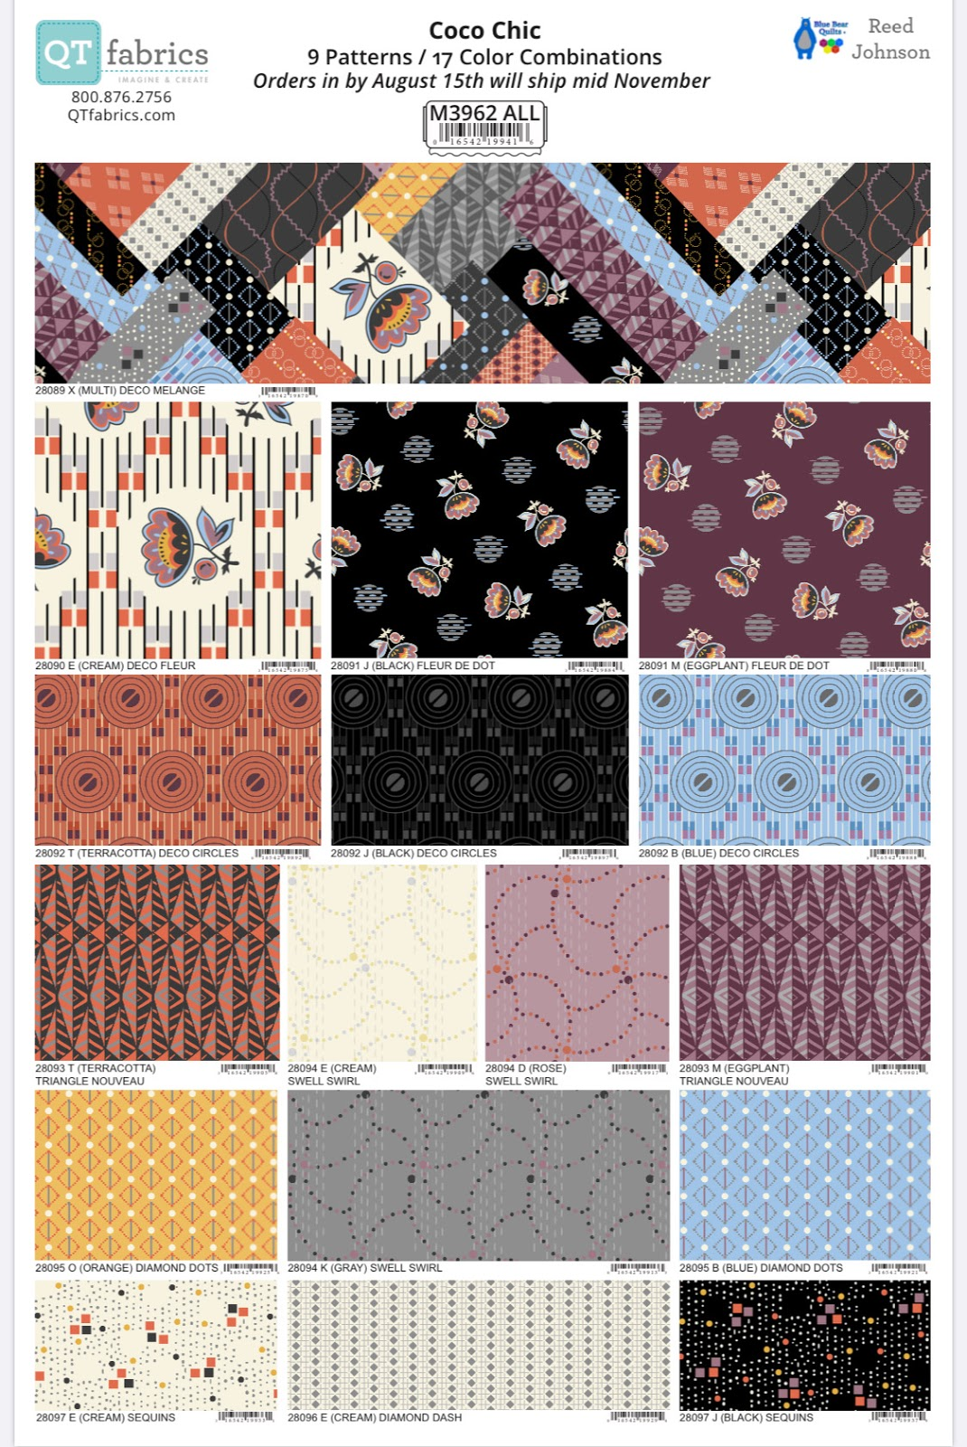

Here are some great project ideas using this fabric collection; like these two quilt patterns by Blue Bear Quilts.
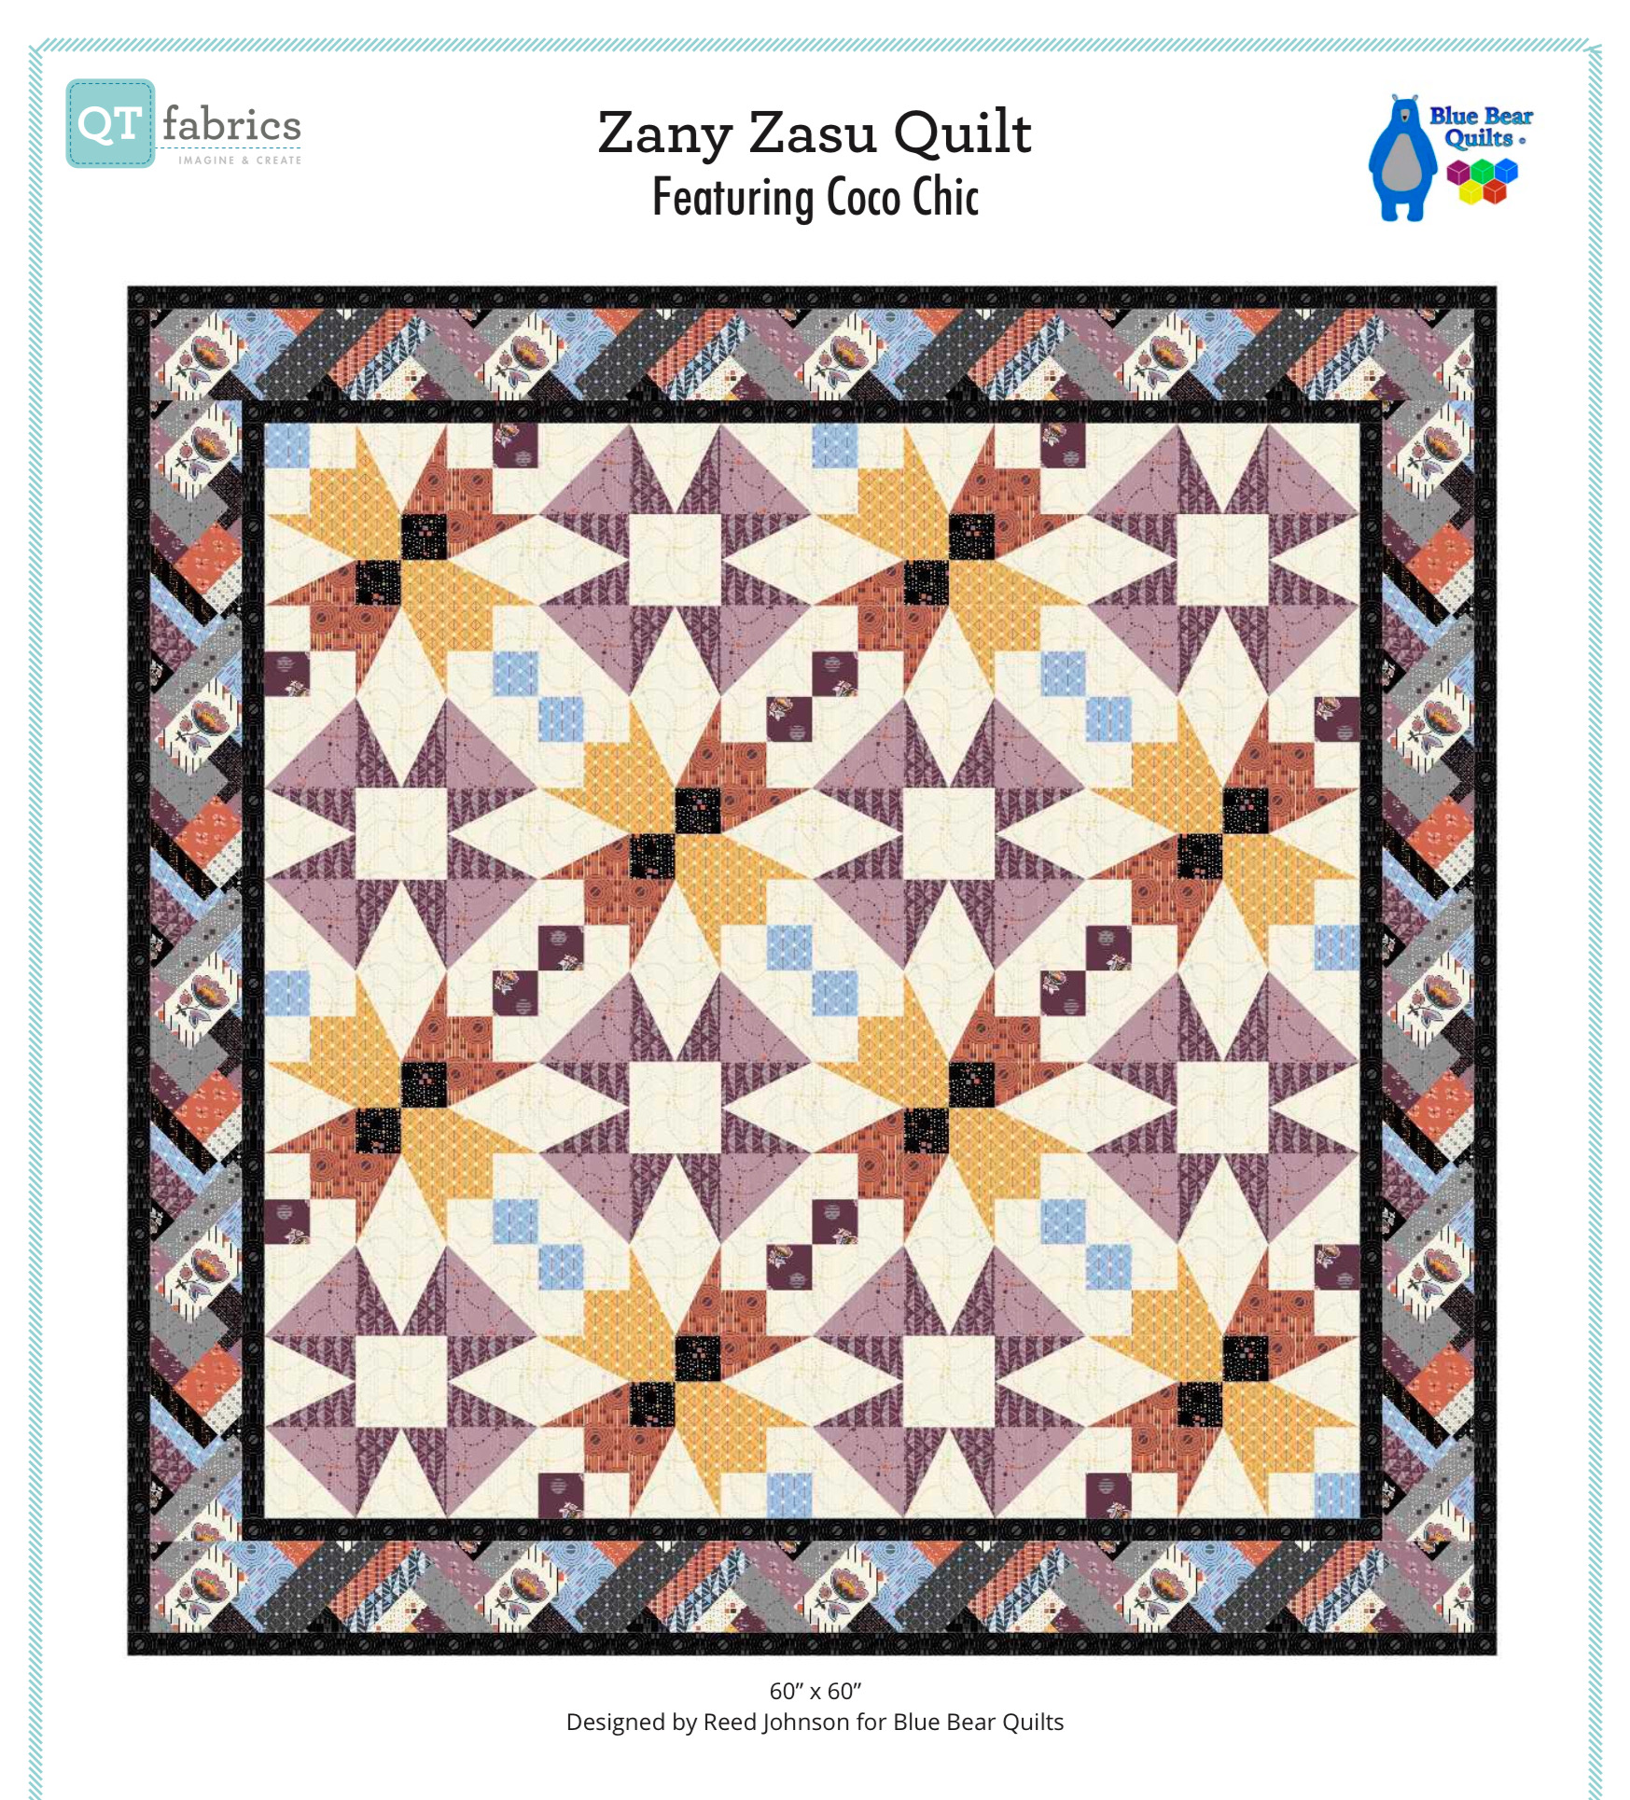
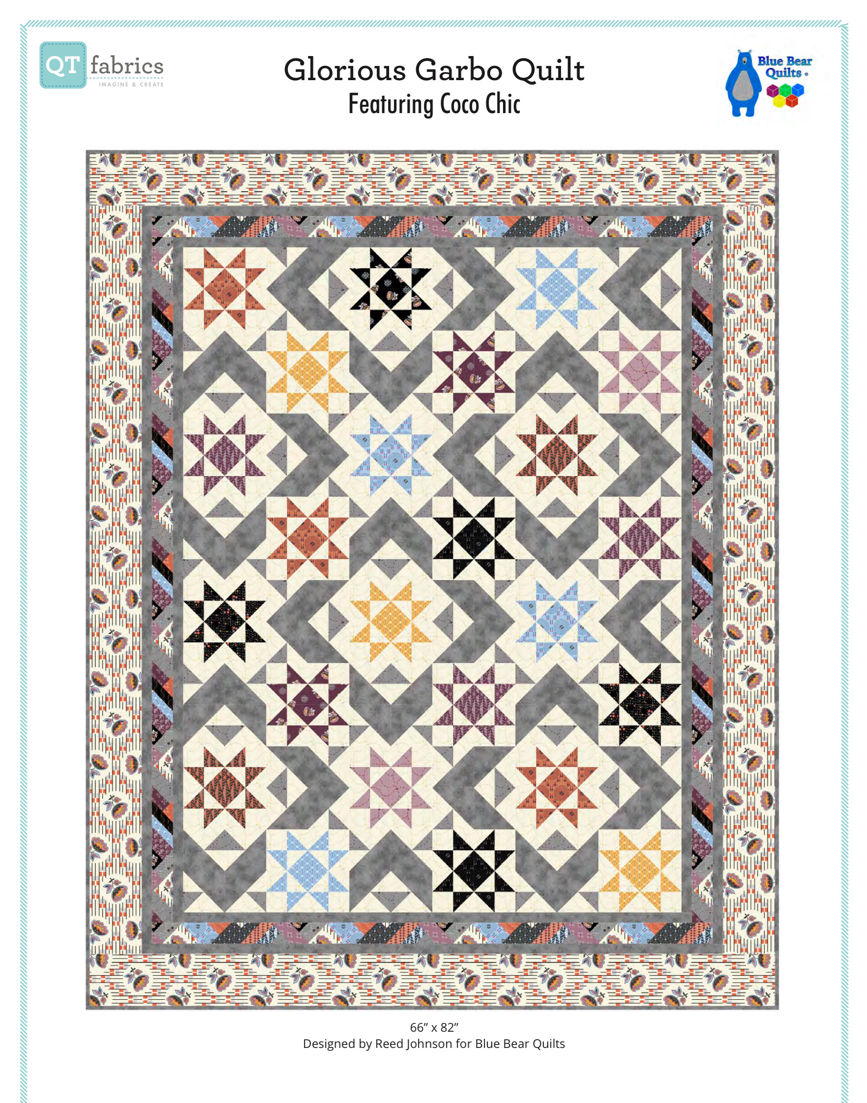

Or, this great braided table runner.
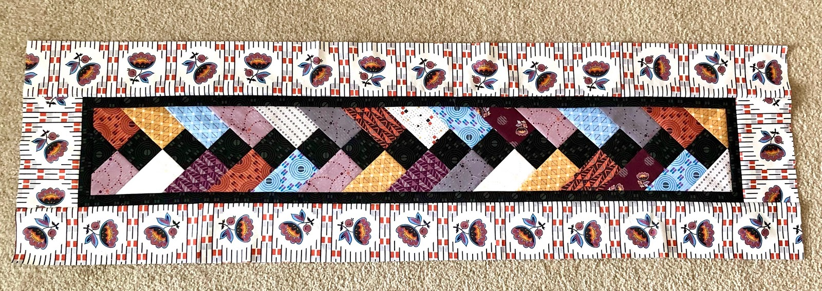

Or, a sewing machine cover byannie.com
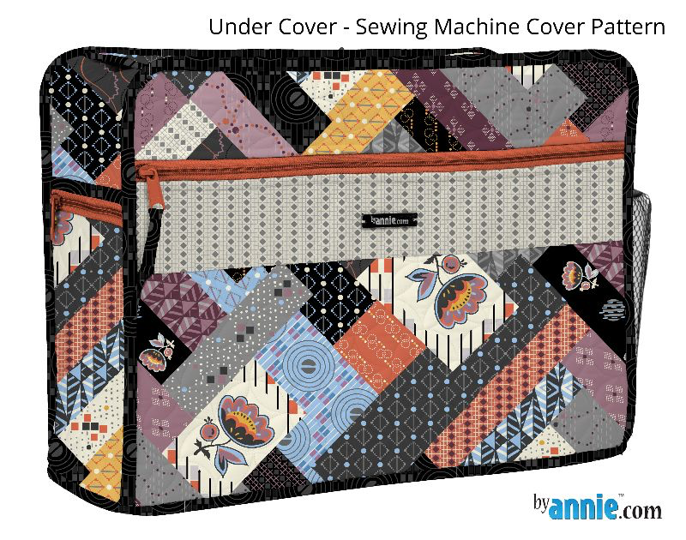

And check out these cool projects made with Coco Chic.
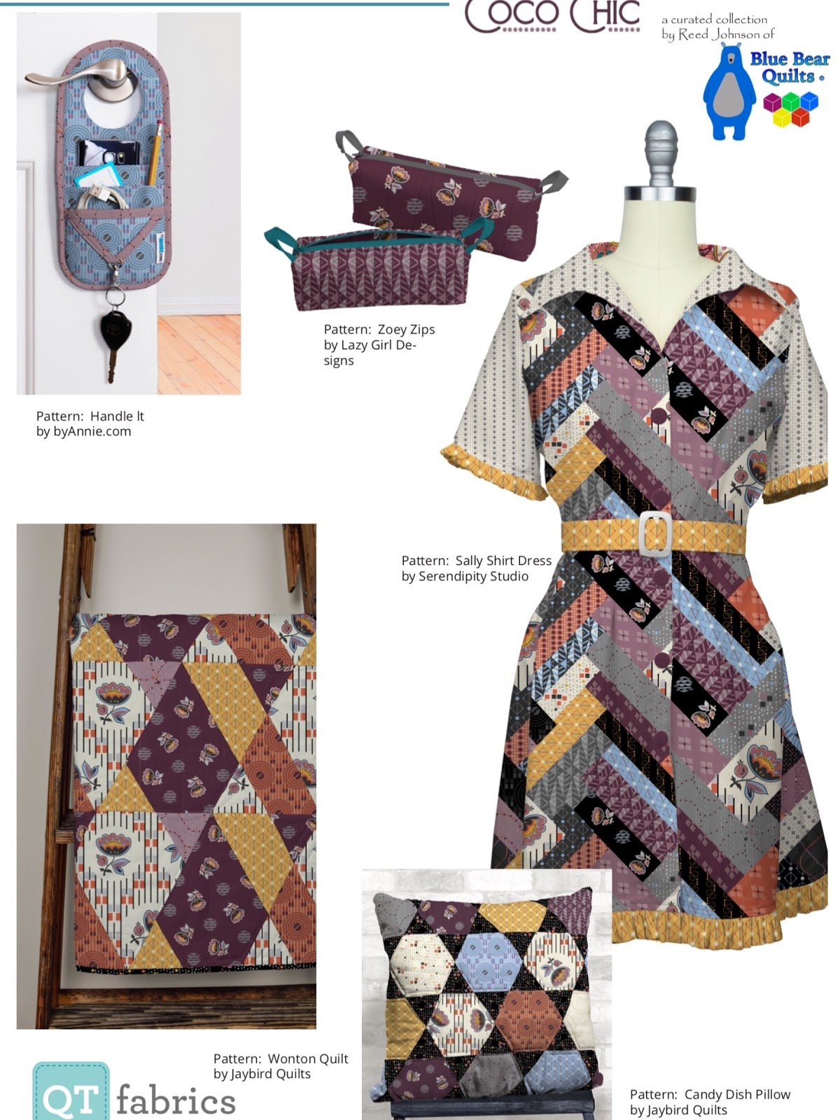
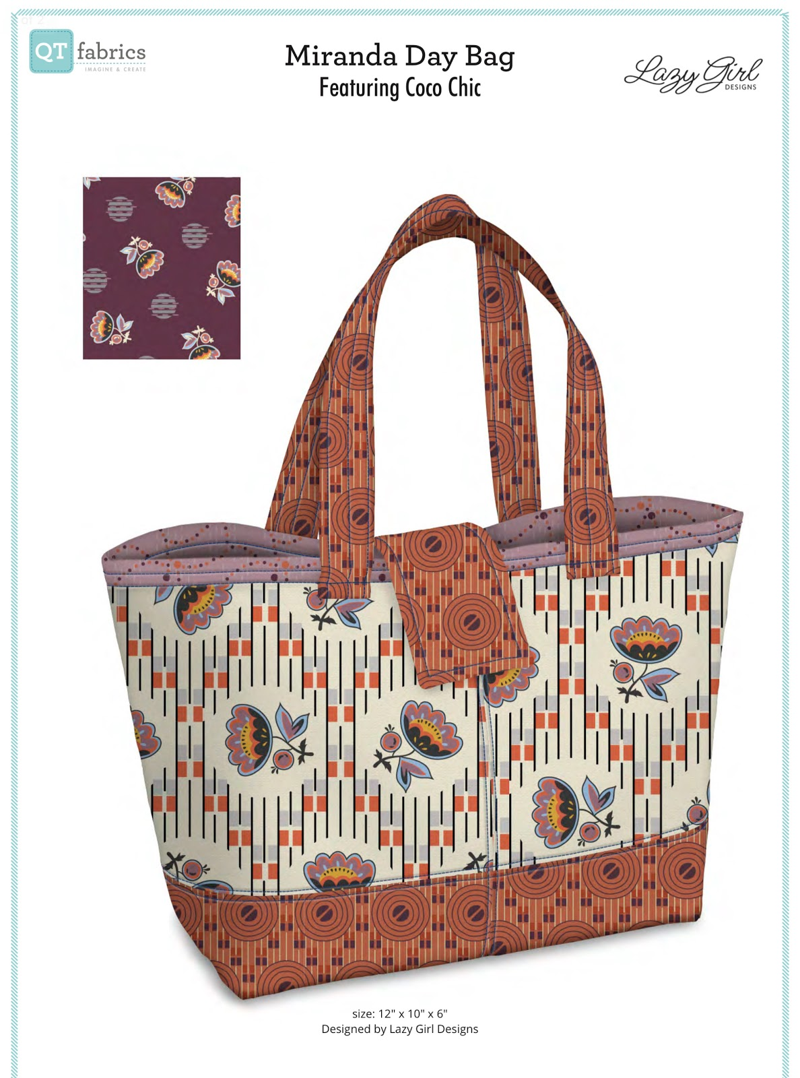

I hope you will consider adding Coco Chic to your inventory as I love it.

Sincerely,

